**Barcodes**

*Surprise:*

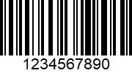

*Colored envelopes pack (16 pcs):*

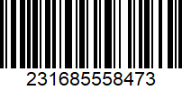

*Jenny's Diary:*

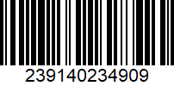

*Nike backpack:*

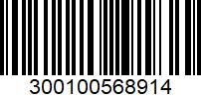

*Walkie-talkie:*

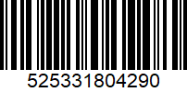

*RC car:*

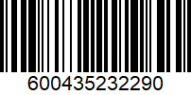

*Old-fashioned sewing machine:*

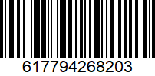

*Fireworks:*

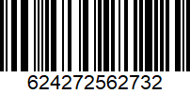

*Red climbing rope for rock climbing:*

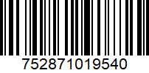

*Classical Guitar – YAMAHA:*

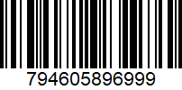

*Glass chess board:*

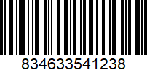

*Dwayne Johnson shampoo:*

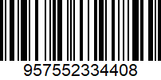

*Black Oud:*

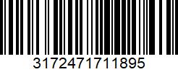

*Assassin's Creed Odyessy - PS4:*

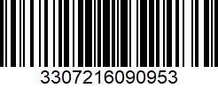

*MUJI marker - 17D:*

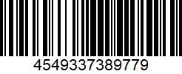

*Overwatch - PS4:*

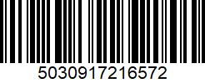

*University book - 5 subjects:*

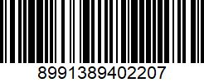

*One Piece manga - Volume 41:*

